MICROSOFT COMPANY CASE STUDY
Student name
Institution
Course
Date

Abstract
Technology has advanced in the recent generation due to the technology companies that been established. Microsoft company is one of the leading companies in the world that is dealing with software and hardware products. The establishment of this company has led to various advancement in technology worldwide. In this case study research, I will be focusing on the Microsoft company regarding its establishment, its status in the market, financial situation, the performance, and analyzing on SWOT of the company.

Introduction
Microsoft company is one of the major software companies in the world. The company was found and developed by William Gates and Paul Allen in the year 1975. Due to the company’s strong foundation, it was able to grow fast and become a multi-billion organization within ten years. The first growth of Microsoft company was also promoted by its vision, “A computer in every desk and every home”, and the excellent marketing strategy of its operating systems. The company has more than 45,000 workers in more than 65 nations globally. The net income is $3.45 billion and 11.36 billion dollars annually. The company has its established strategies that in their daily operations, they consider training and development of the employees is a significant activity of the company. Every new employee in the company is given their roles on the first day of reporting. The people who are usually employed in the organization are those that have exceptional skills in software activities from universities and colleges since they are young men and women that are talented (Gil-Moltó, n.d., p. 98). The qualities of the employees who are hired must be; ambitioned, people who make sound judgement when it comes to business, have knowledge in dealing with technical issues and have high intelligence quotient. The managers of the organization are the ones who hire; hence, they select the best employees that will be dedicated to high incomes and further development. Hiring people who show more interest in the organization is an added advantage to outdoing their enemies. The employees of the company are also motivated by compensation for excellent benefits.

Key financial information
The mission of the company is to ensure that it empowers people and organizations in the world to achieve more income and revenues. The organization has been generating its revenue through the license and support of the software products of the company. They usually do this by designing software, delivering to respective destinations around the world; they manufacture and sale of devices to people (Bhanji, n.d., p. 104). The company annual data that was provided on the website on financial information shows that it has been able to make significant improvements in its various assets, and this indicates that the organization is making more profit. The company was able to make annual revenue of 110.36 billion dollars in the year 2018 and a net income of 16.57 billion dollars in 1028 also.
The following table shows the analyzed financial information of Microsoft company from 2014 to the year 2019 that was obtained for its website.
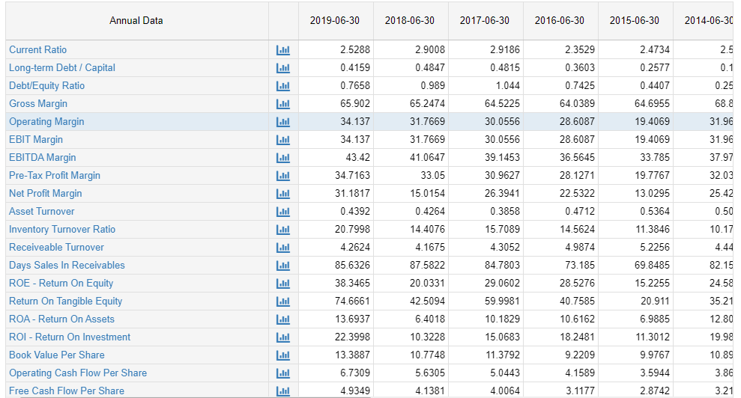

The financial health of the company.
Microsoft company is fast in converting its assets into cash. This is because of the analyzed data on quick ratio and current ratio. The company has the ability to pay off its debts and interest because of its high ratios in earnings before interests and taxes are calculated. This information shows that Microsoft company cannot rely too much on loans to finance the operations of the company. The company can get its profits from the activities of the organization. This information shows that Microsoft company has steady financial progress. For instance, if an investor is looking for recommendations on whether to buy or sell his or her shares in the company, I would recommend that he/she holds the shares. This is because of the company’s high earnings, low debt-equity ratio.
Microsoft’s cash flows are divided into two that is outflows and inflows. These two have a direct relation to the revenues and expenditure of the company’s income statement. The company has been dramatically increasing its cash flows from 2014. The company has high cash flows than the operating activities hence indicating that the company has had proper management of its assets and liabilities. High cash flows have impacted the company significantly due to high income associated with Microsoft company.
The financial ratios of the company are used to measure the actual profit that the company has made and hence, they are able to analyze the amount of profit they have made in the specified year. They are also used in analyzing the general performance of Microsoft company and comparison with its competitors in the market (Lessambo, 2018, p. 300). The ratios that are used for accounting measures return on equity, assets, profit margin and price over earnings.

Return on Equity
This financial ratio in Microsoft company is used to measure the amount of profit that the company has made and get the information on how it will manage its equity. The company has 10.3% on return on equity ratio. For instance, if this percentage is compared to Apple company's capital on the proportion, which is 51.5%, hence this clearly shows that the company has a low rate that might not bring more customers.
Profit margin
Microsoft company has a profit margin of 76.3%, which concludes that the company has a high ratio. The high percentage is usually as a result of the top sakes made an increase in the price of the commodities and the decrease in cost expenses ("Apple surpasses Microsoft as world's most valuable tech company," 2010, p. 67). When the profit margin is compared to Apple's profit margin, Microsoft remains to have a high percentage. Apple company has a profit margin of 42.2%. Thus, Microsoft makes more profit than Apple.
Price over earnings
This financial ratio is used to determine the amount of money that is used on cost expense and the amount that the company is earning. For instance, when price over earnings is compared between Microsoft and Apple, in Microsoft, an investor takes more time to make the amount he or she invested, which is a period of 15 years. When it comes to Apple, the investor takes a period of 13 years to earn back the amount that he or she invested in the company.

Return on Asset
This financial ration in Microsoft company usually shows how the company is able to make a profit before it is on debt, thus showing how the company is efficient in carrying out its operations. When we compare Microsoft's return on asset ratio to Apple, it has a low percentage of 5.9 while Apple has 33.4%.
Industry and competitor analysis
Microsoft company has the most projecting competitors in the industry of technology. The primary competitors are Apple, Google, Oracle, SAP and many more others. The leading competitor in online search is Google. The company is producing various products for its markets in the world, such as manufacturing the hardware devices. Hardware products include tablets and computers. The company is facing such stiff competition in offering its products and services in the technology part because of its vast area of doing its operations. The company has established its focus in software as its main operation in the industry. The product that Microsoft has produced windows operating system which is known worldwide. There are other companies that still offer stiff competition in providing a product similar to windows such as Red Hart that is creating Linux.
Political factors affecting Microsoft industry
The political factors play an essential activity in determining the profits that the company can make in a particular market or region. Because Microsoft company is operating its software activities in multiple nations, it is able to be affected by various political risks in the markets that the company is dealing in. The following are the analyzed political risks that can affect the operations of Microsoft industry.

- The company might encounter trade regulations.
- High taxation in various nations.
- High level of corruption in the technology sector.
- Military invasion risks.
- Political instability in various nations, thus affecting its operations.
- Laws that can be established by law to govern the business of software are anti-trust.
- The government might sometimes favour some companies, and this is an advantage to the Microsoft company.
- The interfering of the government in matters regarding software technology.

Economic factors are affecting the industry.
The economic factors such as inflation, foreign exchange, interest rates and competition have got a significant impact in the Microsoft industry. For a good and stable development of the Microsoft company, it needs to have both macro and micro factors being favourable for its operations. The following are the analyzed economic factors that can affect the Microsoft company.
- The type of economic system that is being used in the regions where the company is carrying out its operations.
- When the government is interfering in the free market of technology.
- How infrastructure is developed in the respective country that it is operating.
- The education level that is present in the economy of business
- How the markets are efficient
- Inflation rates
- High rates of unemployment in the regions it is doing business operations.
- Interest rates
Social factors affecting Microsoft industry
The way people in the society are doing things and the culture change the culture of the company in various ways that are positively or negatively. The way in which people share information and beliefs about Microsoft company significantly affect how the company will be conducting its operations in the market. The social factors that affect the Microsoft industry are analyzed as follows.
- The level of skill of the associated people.
- The type of culture among the people in the region where Microsoft company is operating.
- The attitude of the people
- The level of education
- How society is structured.

Environmental factors.
- Different regions have various environmental factors, and they affect the amount of profit Microsoft company can make in the environment of the markets associated. The following are some of the ecological factors that affect the Microsoft industry.
- The weather that is being experienced in the region of operations.
- How waste is managed in the technology sector in the region of operations
- Change of climate.
- Recycling
- The regulations that have been put in the pollution of water and air in the software business and industry.
Legal factors that affect the Microsoft industry.
The legal factors that can affect the Microsoft industry are discussed as follows
- Employment law
- The protection of data
- The discrimination laws
- The consumer protection
- Health and safety law.
SWOT ANALYSIS
Strengths
The company is a leading software company. Being the world 's most significant software in the world, it was able to generate annual revenue of 23.2 billion dollars in the year 2018/
Has a vast market around the world. The company can carry out its operations in more than 190 nations worldwide, and this has led to the company having more than 700 million of people installing their software.
The constant growth of the company ("SWOT Analysis," n.d., p. 45). The results of financial statements on this website show that the company has a strong base for growth in the technology industry.
The company is the world’s largest company that is involved in having a dominating in most of the markets. The company is ranked to be in position four since it has a market value of 750 billion dollars in the year 2018.
Microsoft has an active advertising stage. The company can advertise itself in every major platform because of its effective strategic policies. This is the reason why the company can attract a lot of users in the world, for instance, the advert that was aired in July impressed many people in the world.
The software is easy to use
The company is known worldwide because of its products and services that are of high technology. Thus, the products are user-friendly and of high quality.
Weaknesses
The cybercrime theft. Due to the increased number of crimes in the cyber industry, they have left Microsoft company in a weak state. People are hacking the windows operating system many times.

The company is lacking innovation. The company is not able to increase the sales of its hardware products such as phones and computers. This is a weakness to the company because its competitors have advanced in technology in their hardware. Hence, they are making more sales.
The company lacks market leadership in the internet browser. The company's competitors have a high share in the browser sector while the Microsoft company is lagging.
The overexposure to the pc market has landed the Microsoft company into a weak state because the merchants are raising prices.
Opportunities
The growth of cloud business. This has led to an increase in services in the cloud, and this is an excellent opportunity for Microsoft to expand its cloud business.
The fast rate of growth in the industries of smartphones has led will give a favourable opportunity to increase its services and products globally.
Microsoft company has an excellent opportunity to venture into the innovation of games. This will lead to the expansion of Microsoft operations.
The company should put more interest in creating alliances with other companies since it will make the company attain a more significant share of the market.

Threats
High competition. The company has been experiencing high competition from Google and Apple companies and this a threat to the company.
The consumers’ change of preferences. People nowadays are paying attention to smartphones; laptops and the problem is that the Microsoft company has not heavily invested in these markets.
High piracy. There has been an increase in cybercrime cases and software; therefore; this has been a threat to the Microsoft security system.
The criticizing of the workforce in the company. The company has an imbalance of its workforce because the number of women compared to men was low. Thus, the human resource policy of the company is severely criticized.

Conclusion
Microsoft company has played a vital role in the software industry and even in social and economic life. The company has promoted employment in the various regions where it has been established. The company should, therefore, be able to build advance more in technology so that it can outdo its enemies like google and Apple. For the company to earn more income, they should consider using useful marketing tools. Another issue that the company should deal with is increasing its partners so that it can make its status in the market stable. The company should develop its development way to produce products that are unique in the market. By establishing its route, it will be able to manufacture distinguishable products, thus leading in the software industry. If an investor wanted to venture into the Microsoft company, I could advise him/her to invest there. The company can manage its resources appropriately, which will result in high performance. The performance of the Microsoft company has increased significantly. This is because the investor will be able to get good profits and return the money invested within a short period.

References
Apple surpasses Microsoft as world's most valuable tech company. (2010). Physics Today. doi:10.1063/pt.5.024368
Bhanji, Z. (n.d.). Microsoft Corporation: A Case Study of Corporate-led PPPs in Education. Public-Private Partnerships in Education. doi:10.4337/9780857930699.00017
Gil-Moltó, M. J. (n.d.). Economic Aspects of the Microsoft Case: Networks, Interoperability and Competition. Microsoft on Trial. doi:10.4337/9781849807142.00023
Lambo, F. I. (2018). Apple and Microsoft Case Study. Financial Statements, 331-351. doi:10.1007/978-3-319-99984-5_23
SWOT Analysis. (n.d.). SpringerReference. doi:10.1007/springerreference_2640

